**CASCADE PUBLIC SCHOOLS**

Student Supply Lists, 2021-22

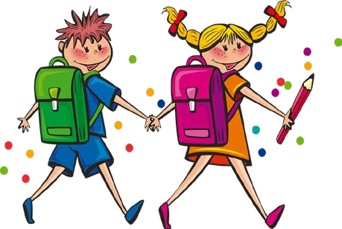

|  |  |
| --- | --- |
| **Early-Kindergarten**  Backpack (full size)  Solid plastic pencil box  #2 Pencils (yellow only)  (2) packs of 24 Crayons  Fiskars Scissors  (8) Glue Sticks - white/clear  (8) Expo markers (black)  (2) Spiral bound wide ruled notebooks  (2) Kleenex boxes  water bottle (one they can open)  (1) pair of clean, new or used gym shoes  (Velcro, unless child can tie shoes)  Extra set of clothes (for accidents)  Paint Shirt | **Kindergarten**  Backpack  Pencil box - preferably plastic  #2 Pencils  Crayons - small box (16 or 24)  Fiskars scissors  (2) glue sticks  Glue - white only, no color/sparkly  Expo Markers (not black)  (1) Kleenex box  (1) pair of clean, new or used gym shoes  Paint Shirt |
| **Grade 1**  Backpack (large enough to fit folder) Pencil Box - preferably plastic  #2 Pencils - yellow only  (2) Pkg pencil top erasers  Crayons, Colored Pencils, Markers  Scissors  (4) Glue Sticks - white or clear only  (2) Highlighters (any color)  (4) Ultra-fine point dry erase markers  (1) Plastic two-pocket folder  (1) Pair of headphones  (1) Kleenex box  Chapstick  (1) pair of clean, new or used gym shoes --(Velcro unless child can tie shoes) | **Grade 2**  Backpack  Pencil Box  #2 Pencils--yellow only  (2) Large pink eraser or pencil top erasers  Crayons  Colored pencils  Scissors  (2) Glue Sticks  White Elmer’s glue  Highlighters (yellow)  Dry erase markers  (2) Spiral notebooks (wide rule)  (1) Pair of headphones  Clorox wipes  (2) Kleenex boxes  (1) pair of clean, new or used gym shoes |

|  |  |
| --- | --- |
| **Grade 3**  Backpack  Pencil box  (2) packages #2 pencils  (2) big erasers  (1) set of colored pencils  Scissors  (2) glue sticks  (3) Highlighters  (4) Dry Erase Markers - fine point  (1) pack of notebook paper  (2) Composition notebooks  (3) folders with pockets  (1) pair of earbuds/headphones  (2) bottles of 8 oz hand sanitizer  (1) box of Kleenex  (1) pair of clean, new or used gym shoes | **Grade 4**  Backpack or bookbag  (1) pencil box  (2) pkg #2 wooden pencils  (1) set of colored pencils  (1) pair of scissors  (1) pkg glue sticks  (2) highlighters  (1) pkg dry erase markers, fine point (preferably black)  (1) pack of filler binder paper  (5) spiral notebooks (50-100 pages per notebook)  (2) folders with pockets  (1) pair of earbuds (PLEASE, NO gaming style  headphones)  (2) bottles, 8oz. hand sanitizer  (1) box of Kleenex  (1) pair of clean, new or used PE shoes |
| **Grade 5**    (1) soft/cloth pencil case  (2) pkg, #2 pencils (plain, wooden)  (1) pkg pink block erasers  (2) pkg Expo markers  (2) pkg wide-ruled notebook paper  (1) pair earbuds (not headphones)  (2) Kleenex boxes  (1) pair of clean, new or used gym shoes | **Grades 6,7,8**  (1) soft/cloth pencil case  (1) pkg pencils  (1) pkg erasers  (2) Small Box Colored pencils  (1) Pair Scissors  (2) Glue sticks  (1) box Expo Markers black fine tip  (1) binder with folders and loose-leaf paper  **OR**  (2) 2 pocket folders with loose leaf paper  (2) Composition notebooks  (1) Set of Earbuds **OR** (1) pair headphones  (1) Wireless mouse for chrome book **(Optional)**  (1) box Kleenex  (1) clean pair of PE shoes |